Task Items

### **Task 1 signup page**

1. First Name and Last Name should be minimum 4 char length and should be only alphabets

2. Email address should be validated and it should be valid email address

3. Password & Confirm password should meet below requirements

1. Should have min 8 character length

2. Atleast 1 capital letter

3. Atleast 1 special charater

4. Atleast 1 number

5. Password & confirm password should be matching

4. Signup button should be disabled if any of the above fileds are invalid

### **Task 2 Dashboard**

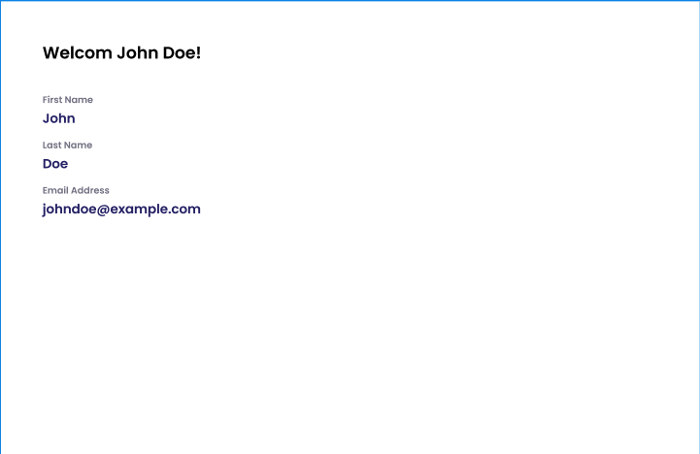

1. Capture the information Firs tName, Last Name, Email address from the signup form

2. Display the information like in the design above

3. If user enters the dashboard page directly, the user should be redirected to the sign up page

### **Task 3 Routing**

1. Use react-router-dom or any other to create route

2. /sign-up -> should go to the signup page

3. /dashboard -> should go to the dashboard page

### **Submitting the assessment**

1. Zip the entire project except `node_modules`

2. Send it to Respective HR